INDIAN SCHOOL AL WADI AL KABIR
Class: VIII | Department : Computer Science | Year :2023-2024
Holiday Homework | Topic: JAVA SCRIPT - HTML
- Write a html code and to make a webpage user interactive add a javascript and get output for following question
- What will be the value of x,y and z after executing the following code in javascript
var x=8+8;
var y=”8”+8;
var z=”Thanks”+8
- Using <H1> tag add the heading for the webpage as “FIND VALUE”
- Using document.write() function display the value
- Using document.write("<br>") display the output in following way
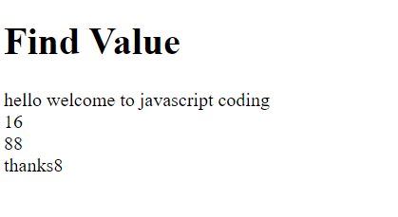

Note: Practice this worksheet , Evaluation will be done after holidays during practical session

